745

Quaker City English Dart League
 | 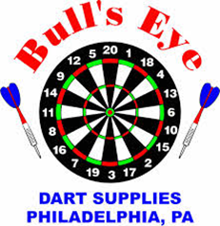 | 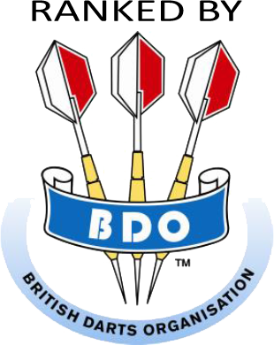 | 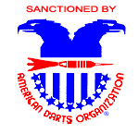
6917 Torresdale Avenue
Philadelphia, PA 19135
(215) 331-6200

Proud Sponsor of the 20th Anniversary Shoot
20,615+ PENNSYLVANIA OPEN

Rae Chesney English Dart Tournament

January 9-10-11, 2015

TOURNAMENT LOCATION: | TOURNAMENT DIRECTOR:
Radisson - Northeast | Mary Jo Chesney
U.S. Route #1 at Old Lincoln Highway | Telephone: (215)-622-8088
Trevose, PA 19053 (just outside of Philadelphia) | Email: maryjochesney@comcast.net
Telephone: (215) 638-8300 – www.radisson.com/trevosepa
Fax: (215) 638-4377 | Website: www.PhillyDarts.com/rcpo
Darters Rates: Doubles & King $93.00 per night | Visit website for Maps - Directions - Results
Book Direct with Hotel • Cutoff Date, December 19, 2014

Day & Time† | F R I D A Y |  | S A T U R D A Y |  |  |  |  |  | S U N D A Y
Day & Time† | 6:00 pm | 8:30 pm | 10:00 am | 11:00 am | 12:30 pm | 1:30 pm | 5:00 pm | 8:00 pm | 10:30 am | 11:30 am | 1:00 pm | 2:00 pm
Event | PRO  Shoot 501** | Blind Draw  501 | Men’s Doubles 501 | Women’s Doubles 501 | Men’s Singles Cricket* | Women’s Singles Cricket* | Mixed Triples 601 | Blind  Draw  501/301/CR | Men’s Double Cricket | Women’s Double Cricket | Men’s Singles 501* | Women’s Singles 501*
 |  |  |  | 32 entries |  | 41 entries |  |  |  | 25 entries |  | 32 entries
Entry Fee | $25 | $15 | $30 | $30 | $25 | $25 | $45 | $15 | $30 | $30 | $25 | $25
Entry Fee | Person | Person | Team | Team | Person | Person | Team | Person | Team | Team | Person | Person
1st | $400 | $500 | $700 | $300 | $800 | $300 | $750 | $440 | $680 | $280 | $700 | $300
2nd | $200 | $250 | $350 | $150 | $400 | $150 | $375 | $220 | $340 | $140 | $350 | $150
3^{rd -} 4th | $100 | $120 | $176 | $80 | $200 | $80 | $180 | $120 | $170 | $70 | $180 | $80
5th - 8th | $50 | $80 | $100 | $40 | $100 | $40 | $ 90 | $80 | $90 | $40 | $100 | $40
9th - 16th | $25 | $50 | $50 | $20 | $50 | $20 | $ 45 | $50 | $50 | - | $50 | -
17th - 32nd | - | $24 | $30 | - | $25 | - | - | $24 | - | - | - | -
Total  Pay Out | $1,200+ | $2,094 | $2,682 | $930  + | $2,800 | $930  + | $2,205 | $2,004 | $2,120 | $720  + | $2,210 | $720  +
† Registration closes 15 minutes prior to starting time †
 | Youth Events - Saturday 9:00 AM by Age Groups & Sunday 9:00 AM Youth/Adult
Warning - Darts is an adult sport. It is dangerous for children to play without adult supervision.  Disclaimer - Amateur Status - The Host Association and/or the ADO assumes no responsibility  for any adverse effects which awards may have on the amateur status of any youth participant. |  | CHILDREN UNDER 18 MUST BE SUPERVISED AT ALL TIMES

* INCLUDES $2 A.D.O SURCHARGE | ** PRO SHOOT 70% PAYBACK, $1,200 MINIMUM GUARANTEED PAYBACK

MALE & FEMALE MVP | TROPHIES FOR ALL EVENTS
- + means To Women’s payout, tournament will add 70% of entry $ for all entries above the listed # of entries  - Go to: www.phillydarts.com/rcpo for the latest information | - MATCHES BEST OF 3 EXCEPT  501 MEN’S SINGLES BEST OF 5 FOR ENTIRE EVENT; 501 WOMEN’S SINGLES BEST OF 5 TOP 8

